M17VLED (17” CCTV LED Monitor)

M19VLED (19” CCTV LED Monitor)

USER MANUAL

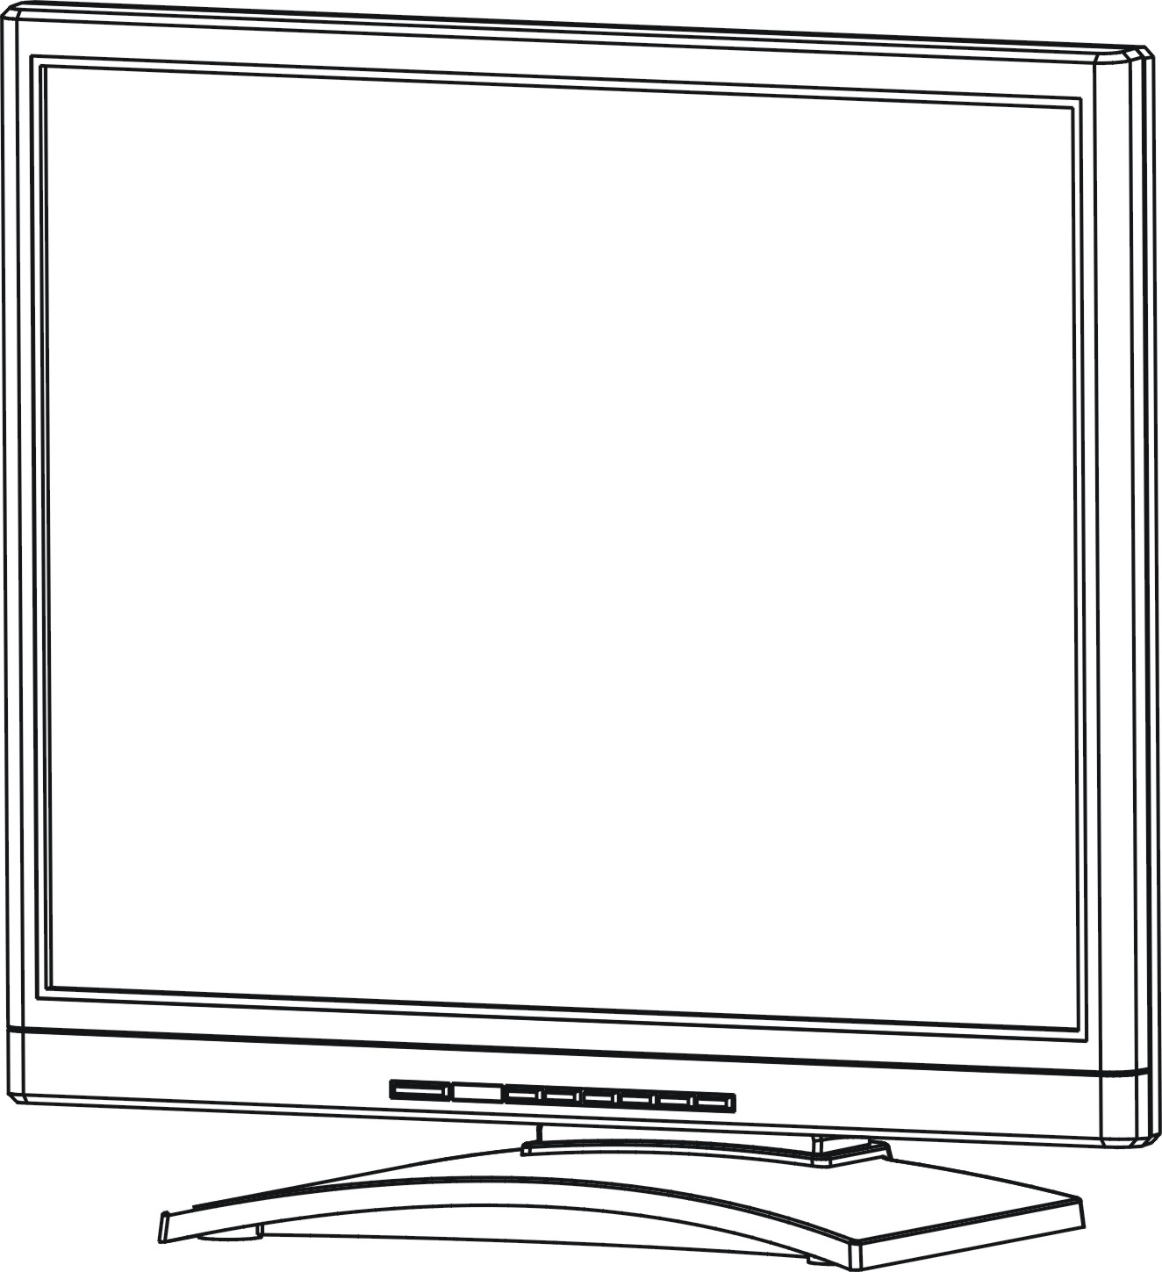

Speco Technologies
200 New Highway
Amityville, NY 11701
800-645-5516
www.specotech.com

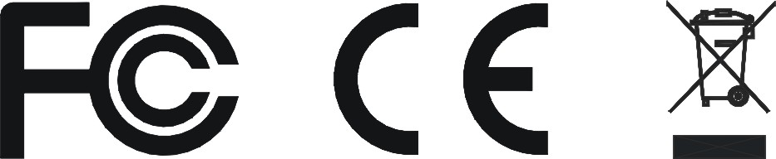

WARNING:

TO REDUCE THE RISK OF FIRE OR ELECTRIC SHOCK, DO NOT EXPOSE THIS PRODUCT TO RAIN OR MOISTURE.
DO NOT INSERT ANY METALLIC OBJECT THROUGH VENTILATION GRILLS.

CAUTION:

Explanation of Graphical Symbols
The lightning flash with arrowhead symbol, within an equilateral triangle, is intended to alert the user to the presence of uninsulated "dangerous voltage" within the product's enclosure that may be of sufficient magnitude to constitute a risk of electric shock to persons.

The exclamation point within an equilateral triangle is intended to alert the user to the presence of important operating and maintenance (servicing) instructions in the literature accompanying the product.

IMPORTANT SAFEGUARDS
Important Information

1. READ INSTRUCTIONS
All the safety and operating instructions should be read before the unit is operated.
2. RETAIN INSTRUCTIONS
The safety and operating instructions should be retained for future reference.
3. HEED WARNINGS
All warnings on the unit and in the operating instructions should be adhered to.
4. FOLLOW INSTRUCTIONS
All operating and usage instructions should be followed.
5. CLEANING
Unplug this unit from the wall outlet before cleaning. Do not use liquid cleaners or aerosol cleaners. Clean only with a dry cloth.
6. ATTACHMENTS
The manufacturer of this unit does not make any recommendations for attachments, as they may cause hazards.
7. WATER AND MOISTURE
Do not use this unit near water. For example, near a bathtub, washbowl, kitchen sink, laundry tub, in a wet basement, or near a swimming pool.
8. ACCESSORIES
Do not place this unit on an unstable cart, stand, tripod, bracket, or table. The unit may fall, causing serious injury, and serious damage to the unit. An appliance and cart combination should be moved with care. Quick stops, excessive force, and uneven surfaces may cause the appliance and cart combination to overturn.
9. VENTILATION
Slots and openings at the rear cabinet and bottom are provided for ventilation, these are to ensure reliable operation of the unit, and to protect it from overheating. These openings must not be blocked or covered. The openings should never be blocked by placing the unit on a bed, sofa, rug, or other similar surface. This unit should never be placed near or over a radiator or heat source. This unit should not be placed in a built-in installation such as a bookcase or rack unless proper ventilation is provided or the manufacturer’s instructions have been adhered to.
10. POWER SOURCE
This unit should be operated only from the type of power source indicated on the rating plate. If you are not sure of the type of power supply to your home, consult your appliance dealer or local power company.
11. POWER-CORD PROTECTION
Power-supply cords should be routed so that they are not likely to be walked on or pinched by items placed upon or against them, paying particular attention to cords at plugs, convenience receptacles, and the point where they exit.
12. LIGHTNING
To protect your unit from a lightning storm, or when it is left unattended and unused for long periods of time, unplug it from the wall outlet and disconnect the antenna or cable system. This will prevent damage to the unit due to lightning and power line surges.
13. POWER LINES
An outside antenna system should not be located in the vicinity of overhead power lines or other electric light or power circuits, or where it can fall onto or against such power lines or circuits. When installing an outside antenna system, extreme care should be taken to keep from touching such power lines or circuits, as contact with them might be fatal.
14. OVERLOADING
Do not overload wall outlets and extension cords, as this can result in a risk of fire or electric shock.
15. OBJECT AND LIQUID ENTRY
Do not push objects through any openings in this unit, as they may touch dangerous voltage points or short out parts that could result in fire or electric shock. Never spill or spray any type of liquid into the unit.
16. HEAT
The product should be situated away from heat sources such as radiators, heat registers, stoves, or other products (including amplifiers) that produce heat.
17. CONNECTING
When you connect the product to other equipment, turn off the power and unplug all of the equipment from the wall outlet. Failure to do so may cause a product damage. Read the owner's manual of the other equipment carefully and follow the instructions when making any connections.
18. LCD
Do not press on or jolt the LCD panel. Doing so may cause the LCD panel glass to break and injury may occur. Should the LCD panel be broken and liquid leaks out, do not inhale or swallow it. Doing so may cause poisoning. If you have got it into your mouth, wash it out and consult your doctor. If your hands or clothes have touched it, wipe them with alcohol and a cleaning cloth and then wash them well.

Safety Precautions

Safety, Regulatory and Legal Information

US Regulatory compliance statements
Your LCD AV has been tested and found to comply with the limits for a Class B digital devices, pursuant to Part 15 of the FCC Rules. These limits are designed to provide reasonable protection against harmful interference in a residential installation. Your LCD AV generates, uses, and can radiate radio frequency energy, and if not installed and used in accordance with the instruction, may cause harmful interference to radio communication. However, there is no guarantee that interference with not occur in a particular installation. If your LCD AV does cause harmful interference to radio or television reception, which can be determined by turning your LCD AV off and on, the user is encouraged to try to correct the interference by one or more the following measures:
- Reorient or relocate the receiving antenna.
- Increase the separation between the equipment and the receiver
- Connect the equipment into an outlet on a circuit different from that to which the receiver is connected.
- Consult the dealer or an experienced radio/AV technician for help.

Warning: Use only shielded signal cables to connect I/O devices to your LCD AV. You are cautioned that changes or modifications not expressly approved by the party responsible for compliance could viold your authority to operate the LCD AV.

FCC STATEMENT
This LCD AV complies with part 15 FCC Rules. Operation is subject to the following two conditions (1) This device may not cause harmful interference. (2) This LCD AV must accept and interference received, including interference that may cause undesired operation.

Canada Regulatory compliance statements
This LCD AV does not exceed the Class B limits for radio noise emissions from digital apparatus as set out in the radio interference regulations of Industry Canada.

Safety Precautions

Federal Communications Commission (FCC) Statement
This Equipment has been tested and found to comply with the limits for a Class B digital device, pursuant to Part 15 of the FCC rules. These limits are designed to provide reasonable protection against harmful interference in a residential installation. This equipment generates, uses and can radiate radio frequency energy and, if not installed and used in accordance with the instructions, may cause harmful interference to radio communications. However, there is no guarantee that interference will not occur in a particular installation. If this equipment does cause harmful interference to radio or television reception, which can be determined by turning the equipment off and on, the user is encouraged to try to correct the interference by one or more of the following measures:
-Reorient or relocate the receiving antenna.
-Increase the separation between the equipment and receiver.
-Connect the equipment into an outlet on a circuit different from that to which the receiver is
connected.
-Consult the dealer or an experienced radio/TV technician for help.

- You are cautioned that changes or modifications not expressly approved by the party responsible for compliance could void your authority to operate the equipment.

This device complies with Part 15 FCC Rules. Operation is subject to the following two conditions:
(1) This device may not cause harmful interference.
(2) This device must accept any interference received including interference that may cause undesired operation

Table of Contents

Warning…………………………………………………………………………………………………2
Important Safeguards…………………………………………………………………………………………3
Safety Precautions……………………………………………………………………………………………4
Table of Contents……………………………………………………………………………………………6
Components…………………………………………………………………………………………………6
Feature…………………………………………………………………………………………………………7
Exploring Your New Monitor…………………………………………………………………………………8
Function Keys Instruction for AV……………………………………………………………………………9
I/O Connection………………………………………………………………………………………………10
OSD (On Screen Display)…………………………………………………………………………………10
AV/S-Video OSD-Image……………………………………………………………………………………11
AV/S-Video OSD-Audio……………………………………………………………………………………12
AV/S-Video OSD-Setup……………………………………………………………………………………13
VGA OSD-Image……………………………………………………………………………………………14
VGA OSD-Audio……………………………………………………………………………………………15
VGA OSD-Setup……………………………………………………………………………………………16
Applicable Timing……………………………………………………………………………………………17
Specification…….……………………………………………………………………………………………18 Wall Mountable………………………………………………………………………………………………19
Dimension…………………………………………………………………………………………………….20

LCD Color Monitor x1
Accessories
(a) Power cord x1
(b) User Manual x1
(c) VGA Cord x1
(d) Mounting base x1
(e) PC audio cord x1
(f) Adaptor x1

Feature

★ Bright, flick-free image
★ Accurate color processing
★ Multi-Scan support
★ Built-in internal amplifier and speakers
★ 1280*1024 SVGA support for computer input (17”/19”)

Exploring Your New Monitor

You can operate your monitor by using the buttons on the front panel.

Front Panel
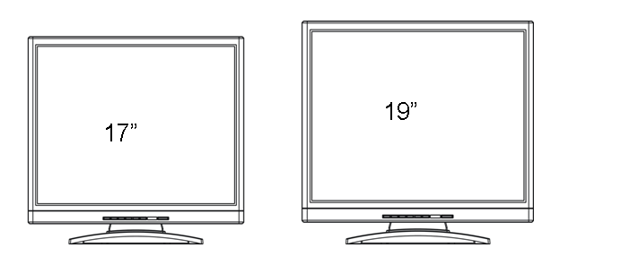

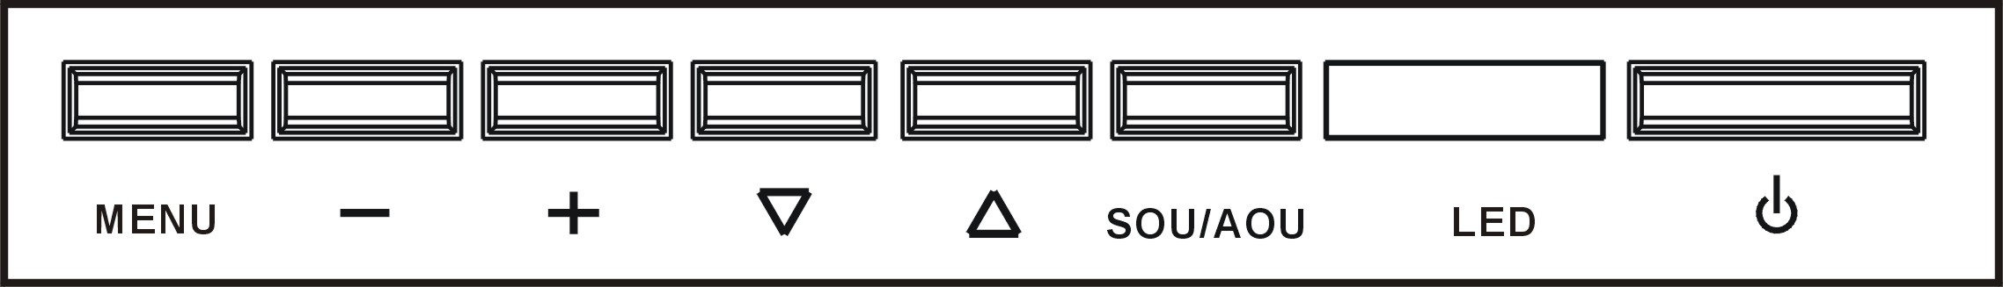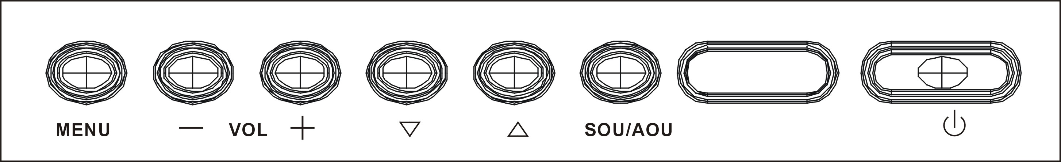

Back Side

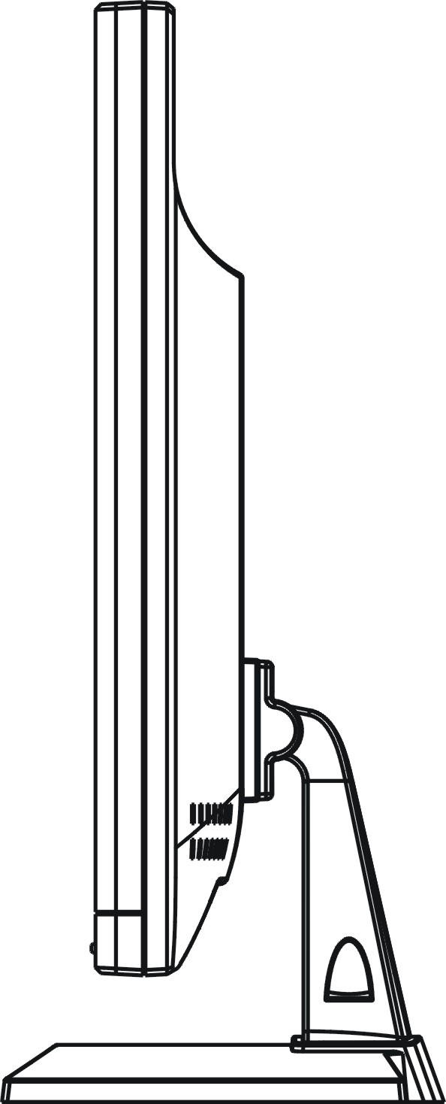
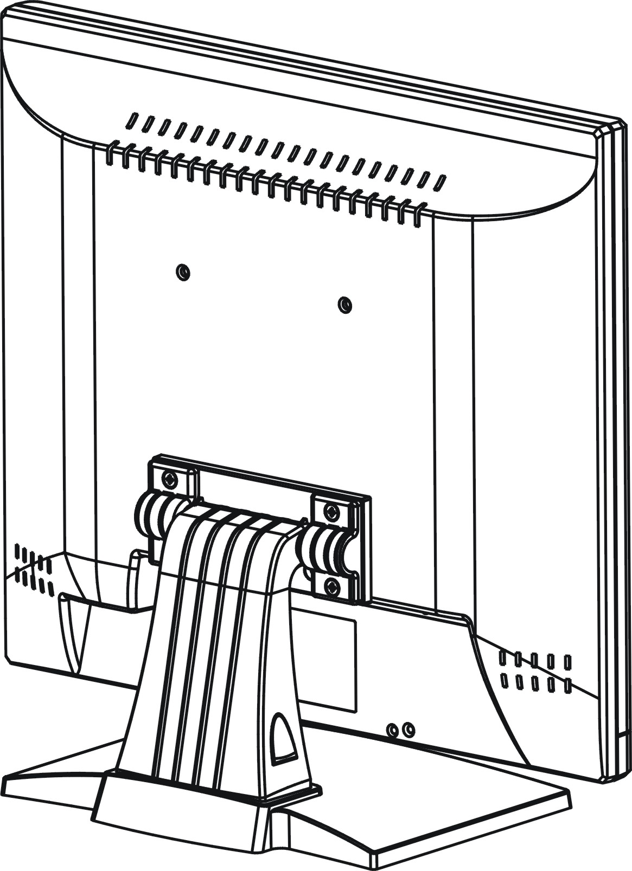

Function Keys Instruction for AV

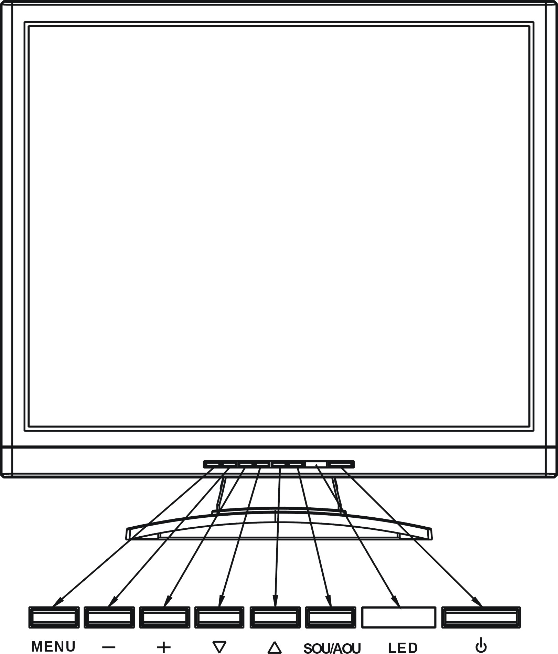

Up: Select menu item

Down: Select menu item

MENU Menu: Push this button to display the main OSD menu / select item of next level

Right : Increase the setting of selected item

Left : Decrease the setting of selected item

SOU/AOU Source: Change input source / to return to last OSD control level

Power: Turn on or off the monitor power

I/O Connection:

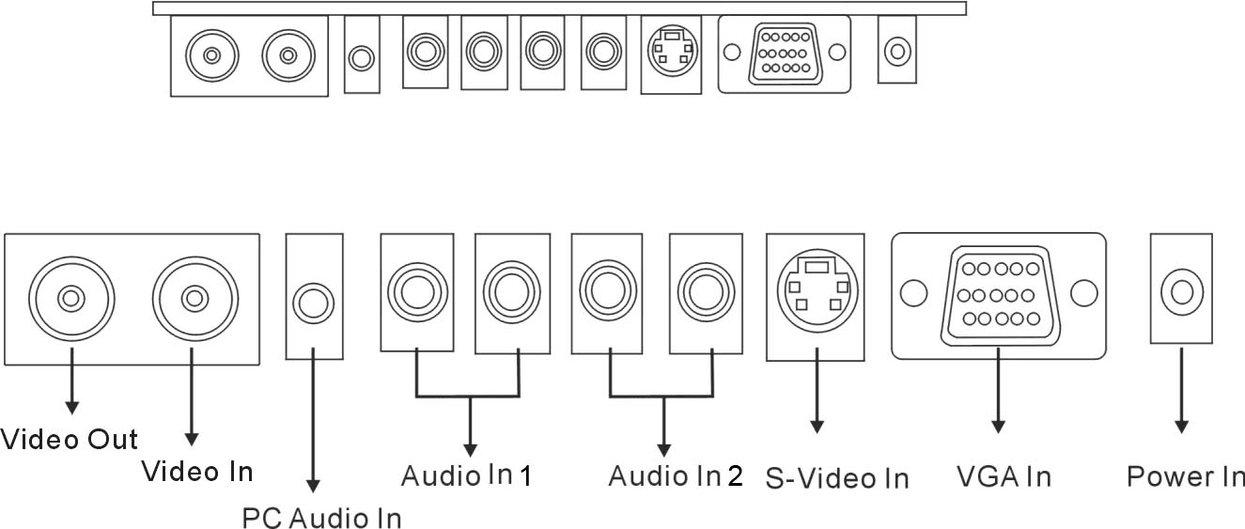

Illustration：
●Video Out is present “AV video out”
●Video In is present “AV video in”
●PC Audio In is present “PC audio in”
●Audio In 1 is present “AV audio in”
●Audio In 2 is present “S-Video audio in”
●S-Video In is present “S-Video video in”
●VGA In is present “PC - VGA signal in”
●Power In is present “Power in”

OSD (On Screen Display)

AV / S-Video OSD - Image
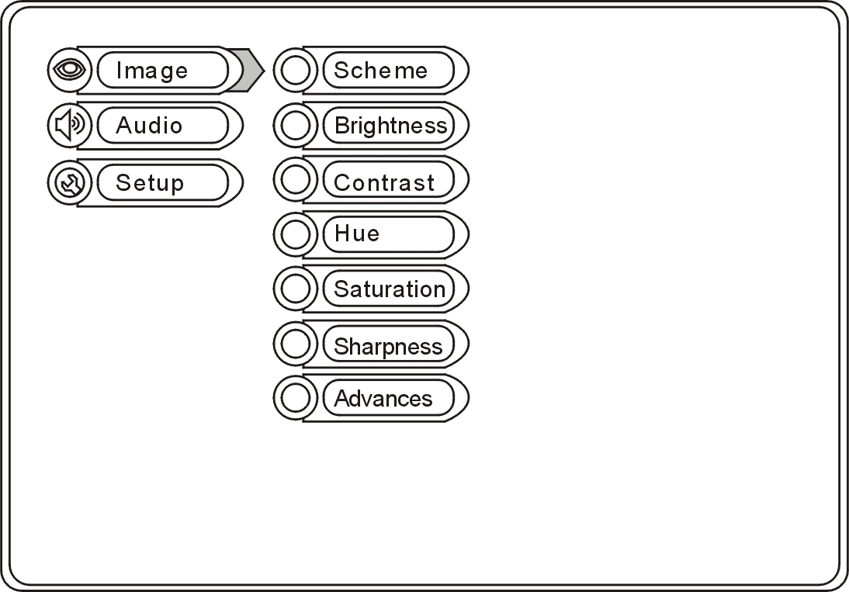

Scheme: Normal / Vivid / Cinema
Brightness: Picture brightness adjustment
Min. ~ Max.:0~100 / Default:70
Contrast: Picture Contrast adjustment
Min. ~ Max.:0~100 / Default:80
Hue: To adjust the color tint value
Min. ~ Max.:0~100 / Default:50
Saturation: Adjusts the saturation of the color
Min. ~ Max.:0~100 / Default:50
Sharpness: Sets the desired sharpening enhancement to the picture
Min. ~ Max.:0~23 / Default:12

AV / S-Video OSD - Audio
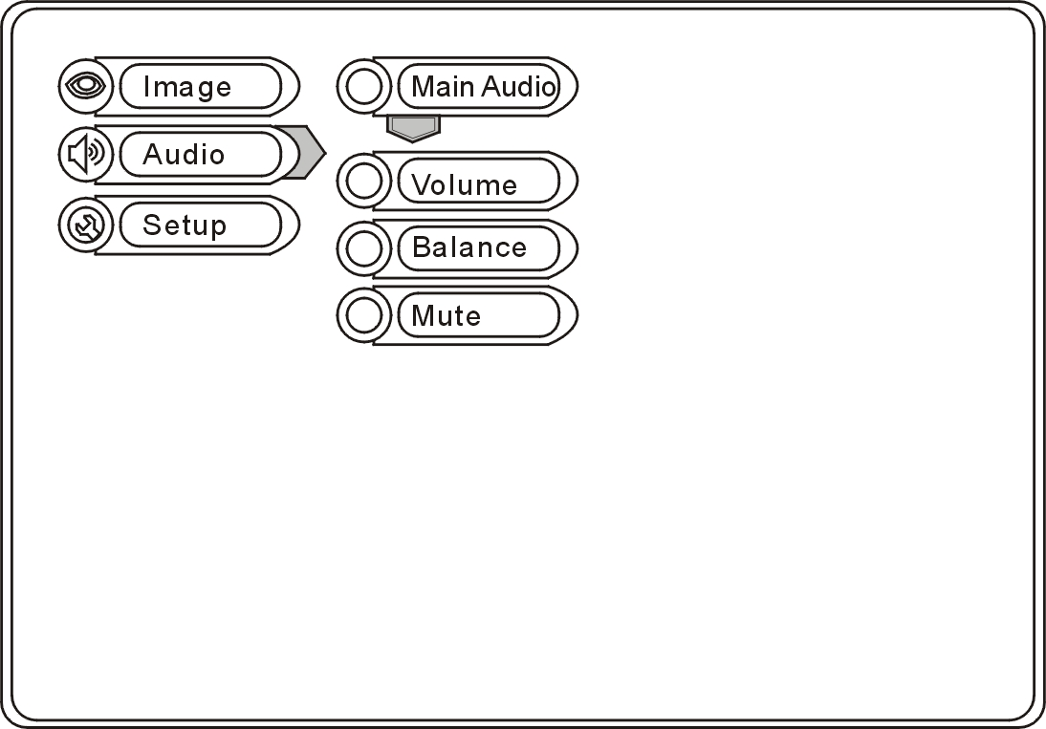

Volume: Controls built-in speakers’ output volumes
Min. ~ Max.:0~29 / Default:20
Balance: Adjusts the volume between speakers
Min. ~ Max.:0~20 / Default:10
Mute: To disable the audio function

AV / S-Video OSD – Setup
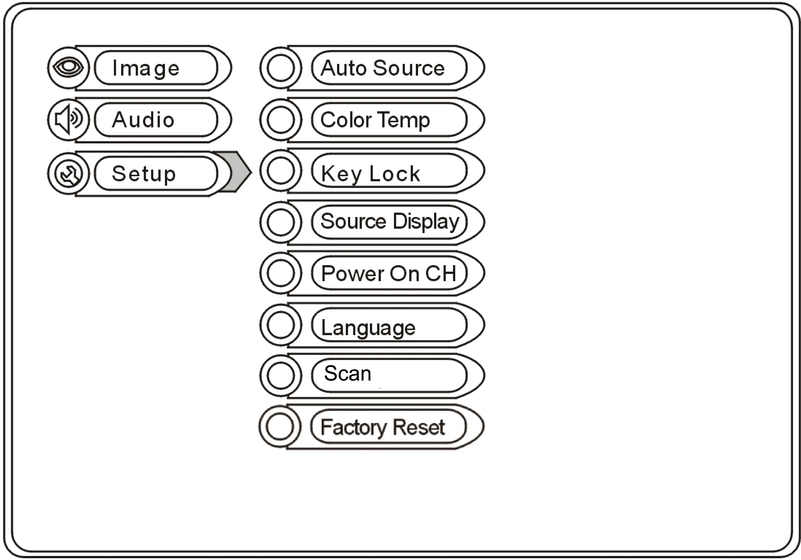

Auto Source: The monitor will auto detect the input source when the
signal is not present
Color Temp: Selects color temperature of either 6500°K or 9300°K
Key Lock: The Key-Lock function is provided to prevent tempering.
To unlock, press “+” and “MENU” button together
Source Display: This function is to allow the channel title to be displayed on
the monitor
Power On CH: This function is to assign a specific input source when turn
the monitor ON None / AV / S-VIDEO / VGA
Language: English / Dutch / Spanish / Italian / German / French
Scan: Full / Under / Over
Factory Reset: Restore all settings to Factory default

VGA OSD - Image
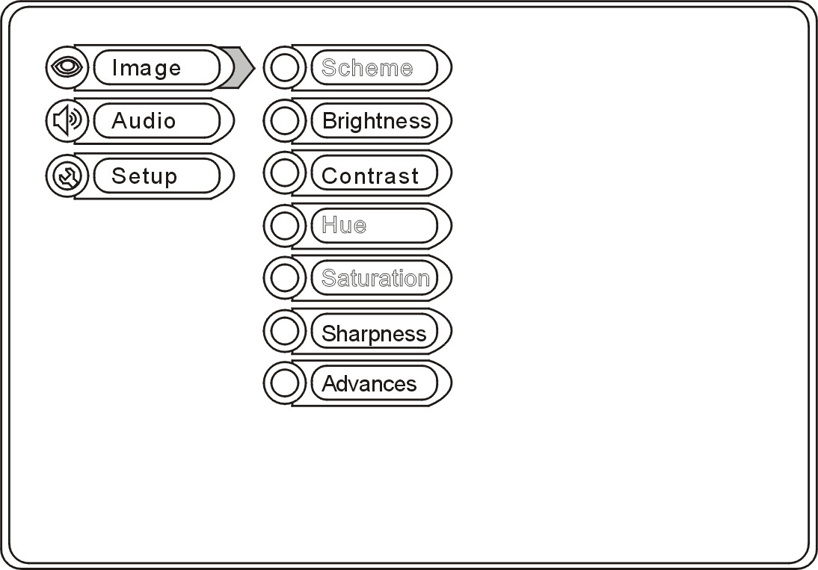

Brightness: Picture brightness adjustment
Min. ~ Max.:0~100/ Default:70
Contrast: Picture contrast adjustment
Min. ~ Max.:0~100 / Default:80
Advanced:
●Auto Adjust: VGA signal auto detection and adjustment
●Image Pos: Image position adjustment include H. V.
●Phase: It adjusts the sampling phase across one pixel time. When
the phase is not adjusted properly, the picture will be unclear Therefore this value should be carefully adjusted
Note: improper adjustment will cause image failure
●Clock: It adjusts the numbers of the pixel clock across one line time
Therefore it can affect the picture position and size
Note: improper adjustment will cause image failure

VGA OSD - Audio
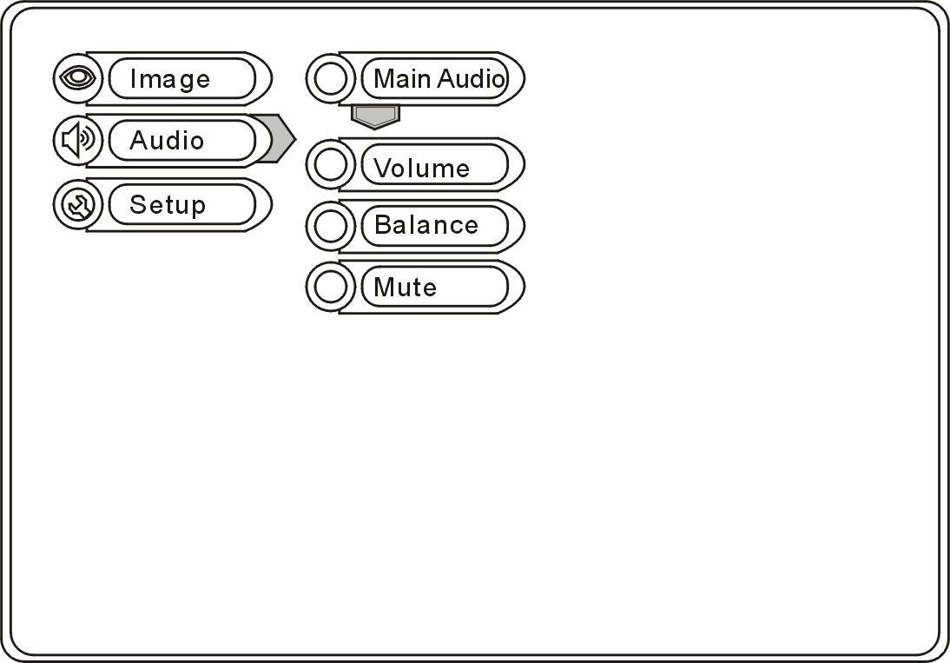

Volume: Controls built-in speakers’ output volumes
Min. ~ Max.:0~29 / Default:20
Balance: Adjusts the volume between speakers
Min. ~ Max.:0~20 / Default:10
Mute: To disable the audio function

VGA OSD - Setup
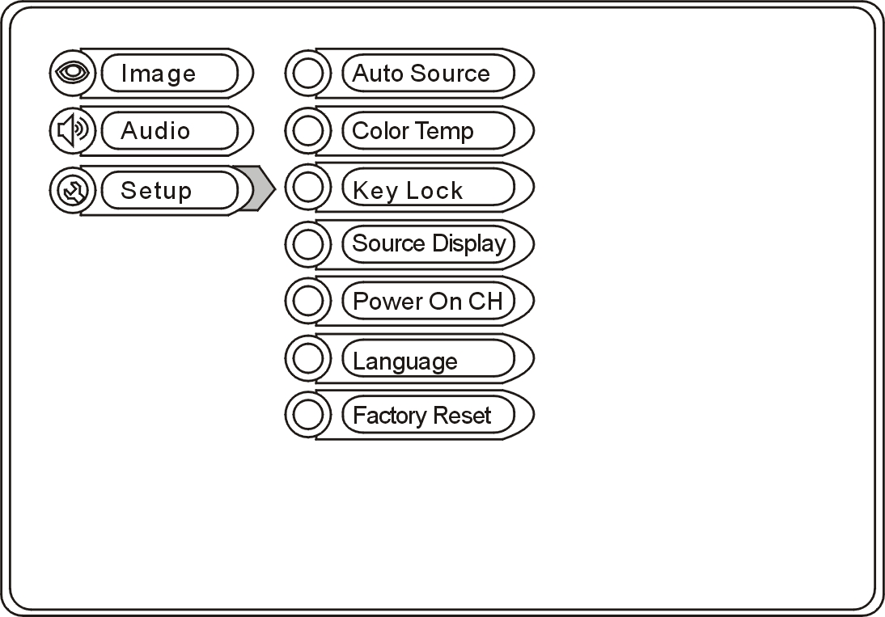

Auto Source: The monitor will auto detect the input source when the signal is not present
Color Temp: Selects color temperature of either 6500°K or 9300°K
Key Lock: The Key-Lock function is provided to prevent tempering.
To unlock, press “+” and “MENU” button together
Source Display: This function is to allow the channel title to be displayed on the monitor
Power On CH: This function is to assign a specific input source when turn the monitor ON None / AV / S-VIDEO / VGA
Language: English
Factory Reset: Restore all settings to Factory default

Applicable Timing

VGA Timing
There are a total of 11 timing modes that can be saved in memory by FIFO detecting architecture.
VGA Support Timing

Mode | No. | Resolution | H Freq. (kHz) | V Freq. (Hz) | Pixel clock  (MHz) | 17” | 19”
 |  |  |  |  |  | 1280*1024  75Hz | 1280*1024  75Hz
VGA | 104 | 640x480@60 | 31.469 | 59.940 | 25.175 | ˇ | ˇ
VGA | 105 | 640x480@72 | 37.861 | 72.809 | 31.500 | ˇ | ˇ
VGA | 106 | 640x480@75 | 37.500 | 75.000 | 31.500 | ˇ | ˇ
SVGA | 108 | 800x600@60 | 37.879 | 60.317 | 40.000 | ˇ | ˇ
SVGA | 109 | 800x600@72 | 48.077 | 72.188 | 50.000 | ˇ | ˇ
SVGA | 110 | 800x600@75 | 46.875 | 75.000 | 49.500 | ˇ | ˇ
XGA | 111 | 1024x768@60 | 48.363 | 60.004 | 65.000 | ˇ | ˇ
XGA | 112 | 1024x768@70 | 56.576 | 70.069 | 75.000 | ˇ | ˇ
XGA | 113 | 1024x768@75 | 60.023 | 75.029 | 78.750 | ˇ | ˇ
SXGA | 114 | 1280x1024@60 | 63.980 | 60.000 | 108.000 | ˇ | ˇ
SXGA | 115 | 1280x1024@75 | 79.976 | 75.025 | 135.000 | ˇ | ˇ

PC RGB Input
Input Signal | Analog RGB 0.7Vp-p
Input Impedance | 75 Ohm ± 2%
Polarity | Positive, Negative
Amplitude | 0 ~0.7 ± 0.05Vp
Multi-mode Supported | Horizontal Frequency: 30~80KHz  Vertical Frequency: 50~75Hz

Power Supply

Input Voltage | 100~240VAC, 50/60Hz
Output Voltage | +12V DC, 5A

Power Consumption

Power Management | On: 25W max. (Green LED)  Off: 2.5W max. (Red LED)
Environment

Operation Condition | Temperature | 0°C to 50°C / 32°F to 122°F
 | Relative Humidity | 20% to 85%
Storage Condition | Temperature | -10°C to 60°C / 14°F to 140°F
 | Relative Humidity | 5% to 85%

Specification

Model | 17” | 19”
Display Resolution (Panel) | 1280 x 1024@75Hz | 1280 x 1024@75Hz
Active Area (mm) | 337.920 (H) x 270.336 (V)mm | 376.32(H) x 301.056 (V)mm
Pixel Pitch | 0.264mm | 0.294mm
LCD Profile Ratio | 5:4
Display Color | 16.7M colors
Brightness (Central) | 250 cd/㎡ Typ.
Contrast Ratio | 800 : 1 typ. | 1000 : 1 typ.
Viewing Angle | Left 80°/Right 80°  Up80°/Down 80° | Left 85°/Right 85°/  Up 85°/Down 85°
Response Time | 5ms
Input Voltage | 96-256Vac, 60Hz/50Hz
Video Input | D-SUB 15 pin x 1, Video In x 1 (BNC), S-Video In x 1
Video Output | Video loop Out x 1 (BNC)
Audio Input | Audio In x 2, PC-Audio In x 1
Speaker | 1W + 1W
Power Consumption | 25W
Operation Temperature | 0 to 50℃ (32 to 122℉)
Storage Temperature | -10 to 60℃ (14 to 140℉)
(∗1) The brightness spec. Is from panel spec.
(∗2) It is not guaranteed for all the specified range.
Design and Specifications are subject to change without notice.

Wall mountable
Wall Mountable

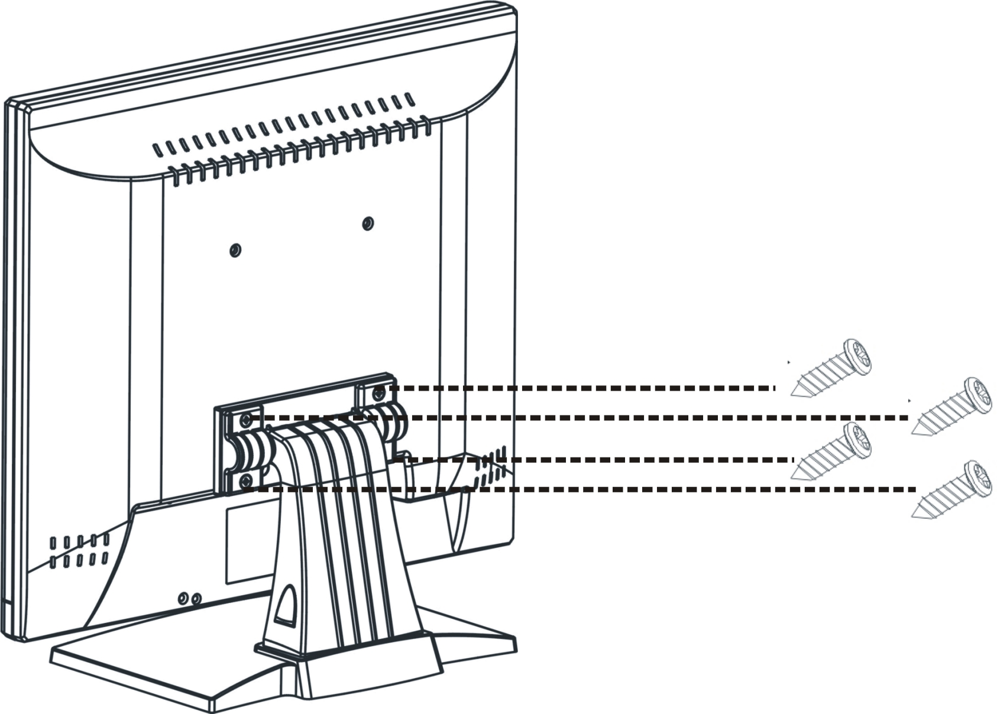

User please use the correct screw type when installation.

The desktop bracket and mount type bracket can use the same screw

Dimension

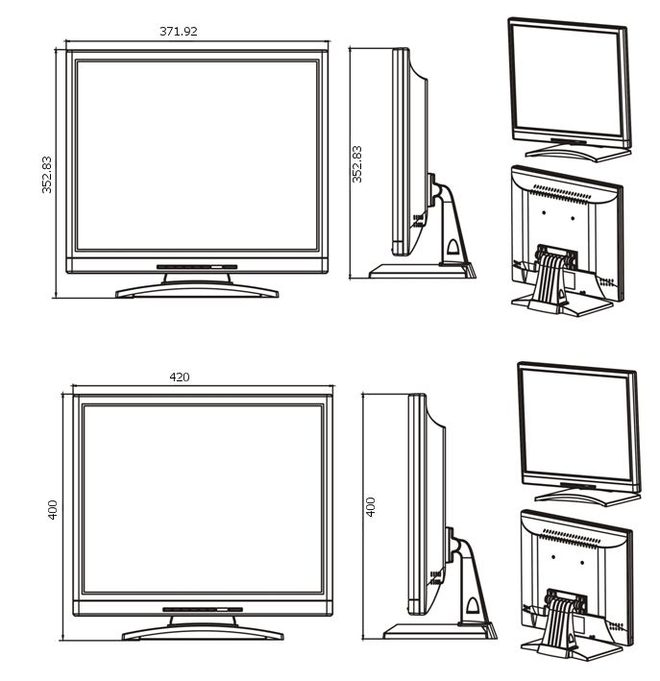

17” LCD

19” LCD

